THEATRE I (B): INTRO TO THEATER
Mrs. Justine Mackey
Class meets- Even Days 8th block
Email: JMackey@rockingham.k12.va.us​
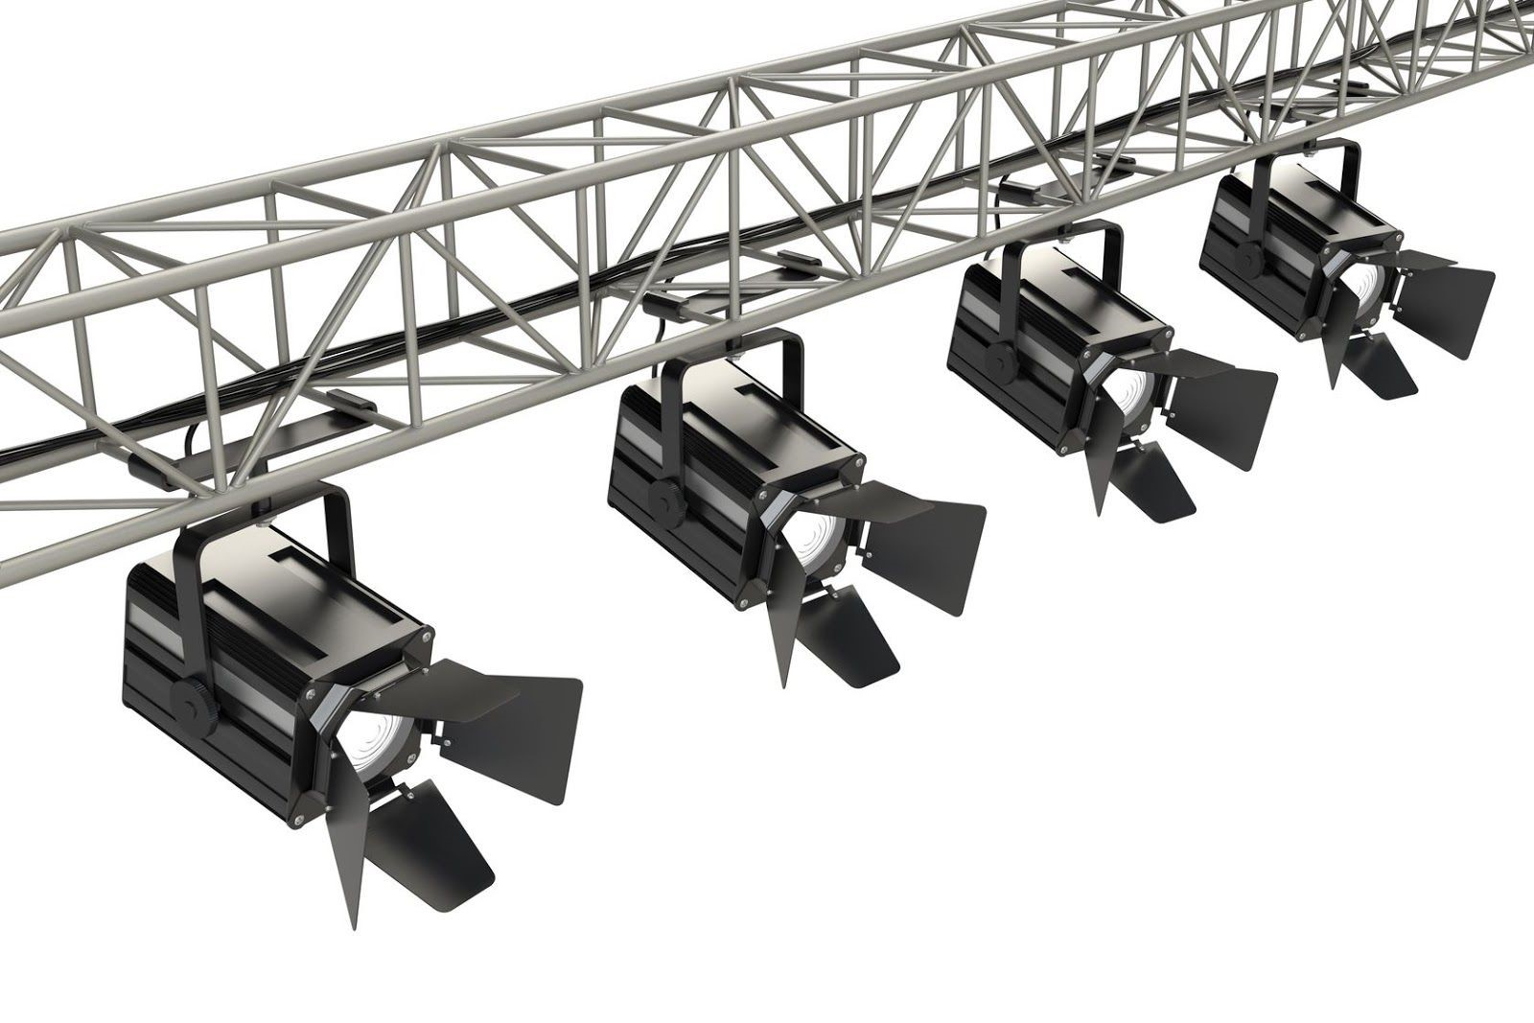

Room 24 ­ “The Drama Room” ­ “The Blackbox”
SPOTSWOOD HIGH SCHOOL 540-289­3100
www.spotswoodtheatre.weebly.com
Planning Period (best time to reach me): odd days- 3rd clock, even days 4th block

Overview:
The course will focus on basic introductory acting skills, improve the speaking voice, warming up the body, Viewpoints, ensemble trainings, breathing and dramatic performance. Students will learn the essentials for performance and the value of being able to present material to their peers while also critically engaging with their peers’ presentations. Because this class involves regular in-class performance and critique, attendance, preparation, and demonstration of the course goals are essential.

Course Objectives: (What I hope you get out of the class)
❏ Enjoying performing and performances
❏ Taking care of your body and self in theatre
❏ Enjoying the collaborative ensemble process with others
❏ Developing the skills necessary to interpret, develop basic production

Projects and Activities we will try to do this year:​
❏ Original playwrighting and production
❏ Clowning
❏ Presenting to the school
❏ Story telling
❏ On the spot challenges
❏ Create a gestural score
❏ learn basic Viewpoints vocabulary

Student Material List:
❏ 3 Ringed Binder filled with loose-leaf lined paper.
❏ 1 Notebook
❏ Pencils and Pens
❏ Highlighters
❏ A pack of index cards
❏ A separate pocket folder with clasps

Play proposal: Students will propose an idea for a one act play to the rest of the class that you will write. Plays must include 5-6 actors and not exceed 20 minutes. After all students propose we will vote on the top 5 winners. From there we will divide into groups/casts and begin rehearsing.

One Act Play Proposal: Students will propose an idea for an already written one act play to the rest of the class. Plays must include at least 3 actors and not exceed 30 minutes. After all students propose we will vote on the top winners. From there we will divide into groups, audition and then cast and begin rehearsing.

Play Readings: This semester we will read 3 plays in class. Each play will introduce students to assorted styles and concepts of theatre.

Viewpoints Training: Viewpoints is a philosophy translated into a technique for training performers, building ensemble, and creating movement for the stage.

Student Assessment:
❏ Class participation, Homework, Quizzes, Presentations & Performances

Grades: will be determined through the evaluation of the following types of work​ and assessments. Grades will be tallied on a total points system for each assignment. Year End Grades average the 2 Semesters together.

Classwork: ​ The class is centered around “doing” and “producing” and “bringing things to life.” Many times, we will learn and study a particular topic before actively applying it.

Participation: ​ Drama is about being involved in a focused manner. Participation involves volunteering, getting up and doing something, voicing opinions, cleaning up, writing, reading, thinking and reflecting.

Projects: ​ Theater involves collaboration between people often with different visions and voices. As students of Theater, you will be involved in several projects with a focus working alongside fellow students. The projects will involve the planning phase, the delegation of work responsibilities, the presentation and the reflection.

Oral presentations: You will have 3 personal oral presentations this year; A children’s story, a monologue, and a dialogue. (See calendar)

Quizzes: ​ Occasional, to keep you on your toes :)

Portfolio: ​ A standalone folder will be created to house your projects, presentations and creations.

Exams: ​ Exam policies will follow handbook guidelines

Late Work: ​ Late assignments or presentations will lose 10% each class period it is not turned in. If you are absent, it is your responsibility to speak to the teacher to find out what work you missed and turn it in the next class period.

Make Up Work: ​ You are responsible for making up all work. Please coordinate with the teacher to make­up work. Anytime I am here will normally work.

Student Expectations: (What is expected of you)
❏ more monkey less talk
❏ Listen, take part and be positive
❏ Be on time and prepared
❏ Follow the student Code of Conduct
❏ No eating or drinking during the class (bottled water is acceptable)
❏ Class begins and ends with the bell

Classroom Rules:
❏ Listen and follow directions.
❏ Raise your hand before speaking.
❏ Keep your hands to yourself and away from another’s property.
❏ Respect your classmates, your teacher and yourself.

Classroom Consequences:
❏ Warning
❏ Conference between student and teacher; Phone call home
❏ Referral (D­Slip)
❏ Conference with Parent and Administrator

Cell Phones:
Turn off, mute and conceal your phone during class. Cell phones are not to be used during class ­ they work against everything we try to accomplish in the theatre classroom. If your phone is out, you will be told to put it away, if it remains out it will be confiscated​. ​

Tardy Policy:
Be on time. Attendance is taken immediately, if you are not here before the bell rings, you will be marked absent or tardy. The school enforces its own tardy policy which may result in detention or even suspension.

Bathroom Policy:
Do not interrupt lecture or instruction time. Be sensible and diligent to catch up on what was missed. Do not go during paired, group work, or presentations. Like cell phone usage there is a courtesy to others.

Jobs:
Students will be asked to apply for jobs for the classroom in which extra credit will be awarded. More to come on this one. :)

“Remind”:​
Remind, formerly Remind101, is a communication tool that helps teachers reach students and parents where they are without directly messaging a student through an app. It can be used to “remind” students of quizzes, tests, appointments, practices and rehearsals. I’ve never used it before and would like to try it out this year. More to come.

Student & Parent Signature Portion – Due Next Class – 8/26
I have read the syllabus and understand the course of study and expectations of this class. ___________________________________________________________ (student signature)

I have looked over the syllabus and understand the expectations of my child and will do my best to support their efforts in the classroom.
______________________________________________________________ (parent/guardian signature)

WEEKLY SCHEDULE
Wednesday 8/22-
Introduction
Review Syllabus
Friday 8/24-
Warming up the body
Tuesday 8/28-
Laban exercises
Thursday 8/30-
Breathing
Tuesday 9/4-
Children’s story rehearsal 1st half
Thursday 9/6-
Children’s story rehearsal 2nd half
Monday 9/10-
Children’s story presentation group 1
Wednesday 9/12-
Children’s story presentation group 2
Friday 9/14
Play writing proposal discussion
Tuesday 9/18-
Warm ups
Ensemble Building
Thursday 9/20-
Warm ups
Ensemble Building
Monday 9/24-
Clowning 1
Wednesday 9/26-
Clowning 2
Friday 9/28-
Play proposal- Vote for top 5 plays
Tuesday 10/2-
Group announcements-Group meetings/ casting
Thursday 10/4-
Group meetings (assign roles: props, costumes, set pieces)
Monday 10/8-
Monologue discussion & choose order
Wednesday 10/10-
Monologue Rehearsal group 1
Friday 10/12-
Monologue Rehearsal group 2
Tuesday 10/16-
Scripts due
Monologue performance Group 1
Thursday 10/18-
Monologue performance Group 2

Monday 10/22-
Group rehearsal
Wednesday 10/24-
Group rehearsal
Monday 10/29-
Group rehearsal
Wednesday 10/31-
Group rehearsal
Friday 11/2-
Group rehearsal & Pick Secret Sonnets
Thursday 11/8-
Warm ups
Group rehearsal
Monday 11/12-
Group rehearsal
Wednesday 11/14-
Group rehearsal
Friday 11/16-
Group rehearsal
Tuesday 11/20-
Group design presentations
Tuesday 11/27-
Group rehearsal
Thursday 11/29-
Group rehearsal
Monday 12/3-
Group rehearsal
Wednesday 12/5-
Group rehearsal
Friday 12/7-
Group rehearsal
Tuesday 12/11-
Group rehearsal
Thursday 12/13-
Group rehearsal
Monday 12/17-
Groups 1 & 2 Present Play
Wednesday 12/19-
Groups 3 & 4, 5 Present Play
Friday 12/21-
Secret Sonnets Party
Friday 1/4-
Post mortem from play presentation
Tuesday 1/8-
Viewpoints training
Thursday 1/10-
Viewpoints training

Monday 1/14-
Scene work discussion
Wednesday 1/16-
Scene work rehearsal groups 1-8
Friday 1/18-
Scene work rehearsal groups 9-16
Wednesday 1/23-
Scene presentations groups 1-8
Friday 1/25-
Scene presentations groups 9-16
Tuesday 1/29-
One act play proposals & Vote
Thursday 1/31-
Auditions for one acts & casting
Monday 2/4-
Group rehearsals
Wednesday 2/6-
Group rehearsals
Monday 2/11-
Group rehearsals
Wednesday 2/13-
Group rehearsals
Friday 2/15-
Group rehearsals
Tuesday 2/19-
Group rehearsals
Thursday 2/21-
Group rehearsals
Monday 2/25-
Read Play 1
Group rehearsal
Wednesday 2/27- Les Mis opens tomorrow
Read Play 1
Group Rehearsal
Friday 3/1-
Read Play 1-Discussion
Tuesday 3/5-
Les Mis discussion & Clean up
Tuesday 3/7-
Les Mis Clean up
Monday 3/11-
Viewpoints/Group 1, 2, & 3 Rehearsal
Wednesday 3/13-
Viewpoints/ Groups 4 & 5 Rehearsal
Friday 3/15-
Groups concept/design presentations
Tuesday 3/19-
Group Rehearsal
Thursday 3/21- (Last day before spring break)
Group Rehearsal
Monday 4/1-
Play Reading 2 &Group meetings
Wednesday 4/3-
Play Reading 2 & Group Meetings
Friday 4/5-
Play Reading 2 & Group Meetings
Tuesday 4/9-
Frantic assembly/ Group 1, 2, & 3 Rehearsal
Thursday 4/11-
Frantic Assembly/ Group 4 & 5 Rehearsal
Monday 4/15-
Frantic assembly/ Group 1, 2, & 3 Rehearsal
Wednesday 4/17-
Frantic assembly/ Group 1, 2, & 3 Rehearsal
Tuesday 4/23-
Class One Act Dress Rehearsal
Thursday 4/25-
Class One Act Dress Rehearsal
Monday 4/29-
Groups 1 & 2 present One Act
Wednesday 5/1-
Groups 2 & 3 present One Act
Friday 5/3-
Groups 2 & 3 present One Act
Tuesday 5/7-
One Act post mortem discussion
Thursday 5/9-
One Act clean up
Monday 5/13-
Play reading 3
Wednesday 5/15-
Play reading 3
Friday 5/17-
Play reading 3
Tuesday 5/21-
Monologue prep workshop
Thursday 5/23-
Monologue prep workshop
Tuesday 5/28-
Final review
Thursday 5/30-
Final review
Monday 6/3-
Final review
Thursday 6/5-
Final

